One-Hot Encoding:
One-Hot Encoding is the data preprocessing technique used to convert categorical values into numerical format that machine learning models can understand. It represents each category as a separate binary column, where a value of 1 indicates the presence of that category and 0 indicates its absence.
Example:
Consider a dataset with fruits their categorical values and prices. Using One-Hot Encoding , we can transform these categorical value into numerical format.
- Wherever the fruit is “Apple”, then the Apple column will have value of 1 while the other fruit columns like Mango or Orange will have 0.
- This pattern ensures that each categorical value get its own column represented with binary values (0 or 1) making it usable for machine learning models.
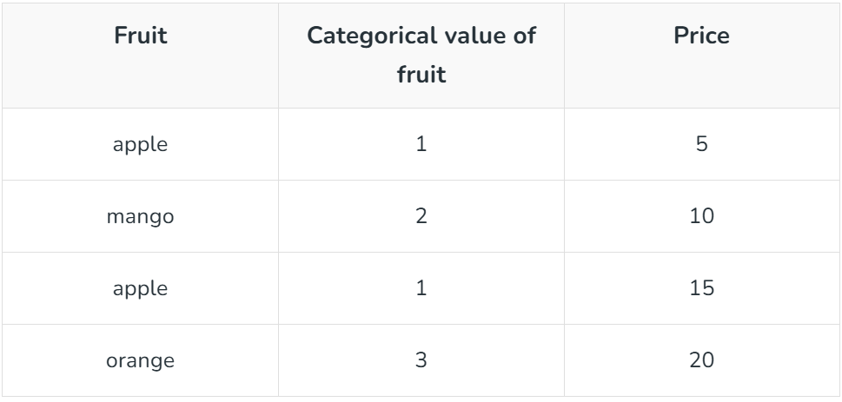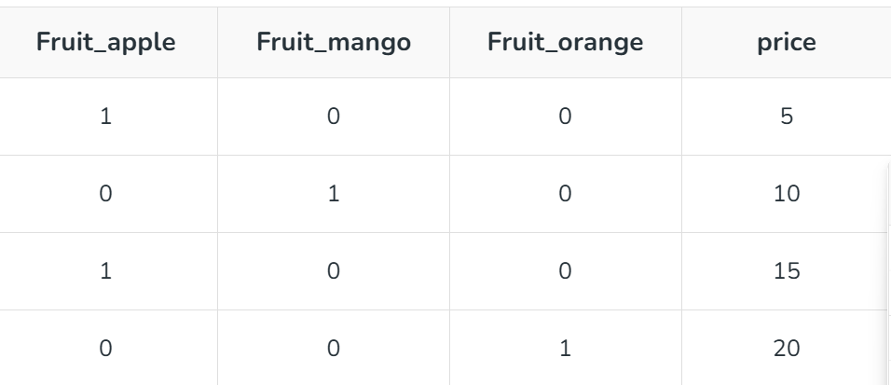

Code:
import pandas as pd
from sklearn.preprocessing import OneHotEncoder

data = {
'Employee id': [10, 20, 15, 25, 30],
'Gender': ['M', 'F', 'F', 'M', 'F'],
'Remarks': ['Good', 'Nice', 'Good', 'Great', 'Nice']
}

# Using Pandas

df = pd.DataFrame(data)
print(f"Original Data:\n{df}\n")

df_pandas_encoded = pd.get_dummies(df,columns=['Gender','Remarks'],drop_first=True)
print(f"One-hot Encoded data using Pandas:\n{df_pandas_encoded}\n")

# Using Scikit Learn
categorical_columns = df.select_dtypes(include=['object']).columns.tolist()
encoder = OneHotEncoder(sparse_output=False)

one_hot_encoded = encoder.fit_transform(df[categorical_columns])
one_hot_df = pd.DataFrame(one_hot_encoded,columns=encoder.get_feature_names_out(categorical_columns))

df_encoded = pd.concat([df,one_hot_df],axis=1)
df_encoded = df_encoded.drop(categorical_columns,axis=1)

print(f"One-Hot Encoded Data using Scikit Learn:\n{df_encoded}\n")

Output:
Original Data:
Employee id Gender Remarks
0 10 M Good
1 20 F Nice
2 15 F Good
3 25 M Great
4 30 F Nice

One-hot Encoded data using Pandas:
Employee id Gender_M Remarks_Great Remarks_Nice
0 10 True False False
1 20 False False True
2 15 False False False
3 25 True True False
4 30 False False True
One-Hot Encoded Data using Scikit Learn:
Employee id Gender_F Gender_M Remarks_Good Remarks_Great Remarks_Nice
0 10 0.0 1.0 1.0 0.0 0.0
1 20 1.0 0.0 0.0 0.0 1.0
2 15 1.0 0.0 1.0 0.0 0.0
3 25 0.0 1.0 0.0 1.0 0.0
4 30 1.0 0.0 0.0 0.0 1.0

Bidirectional LSTM(Long Short Term Memory) in NLP:
Bidirectional LSTM is the extension of LSTM that processes sequences in both forward and backward directions, allowing the model to capture the past and future context.
- Processes sequence in both forward and backward directions
- Captures both past and future contextual information
- More Effective than standard LSTM’s for sequence understanding
BiLSTM consists of two layers:
Forward LSTM : Processes the sequence from start to end.
Backward LSTM : Processes the sequence from end to start
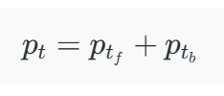
The output of both LSTM combines to get the final output.
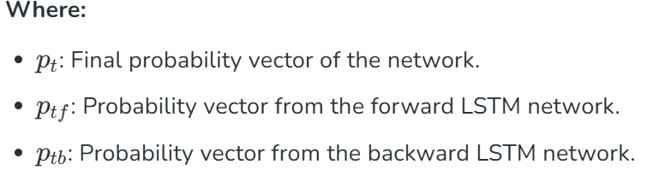
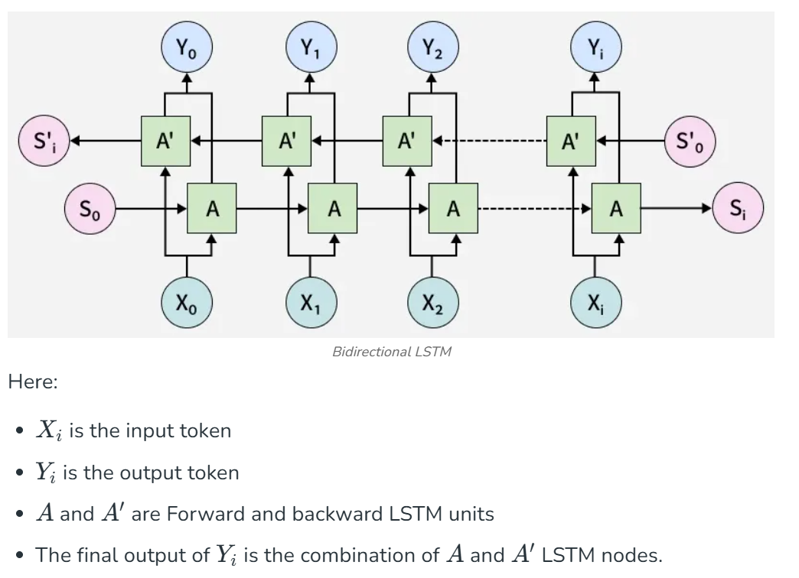
Code:
import tensorflow as tf
import tensorflow_datasets as tfds
import numpy as np
import matplotlib.pyplot as plt

dataset = tfds.load('imdb_reviews', as_supervised=True)
train_dataset, test_dataset = dataset['train'], dataset['test']

batch_size = 32

train_dataset = train_dataset.shuffle(10000).batch(batch_size)
test_dataset = test_dataset.batch(batch_size)

example,label = next(iter(train_dataset))
print("Text:\n",example.numpy()[0])
print("\nLabel:",label.numpy()[0])

vectorize_layer = tf.keras.layers.TextVectorization(output_mode='int',output_sequence_length=100)
vectorize_layer.adapt(train_dataset.map(lambda x,y :x))

model = tf.keras.Sequential([
vectorize_layer,
tf.keras.layers.Embedding(
len(vectorize_layer.get_vocabulary()), 64, mask_zero = True),
tf.keras.layers.Bidirectional(
tf.keras.layers.LSTM(64,return_sequences=True)),
tf.keras.layers.Bidirectional(tf.keras.layers.LSTM(32)),
tf.keras.layers.Dense(64, activation='relu'),
tf.keras.layers.Dense(1)
])

model.build(input_shape=(None,))

model.compile(
loss=tf.keras.losses.BinaryCrossentropy(from_logits=True),
optimizer=tf.keras.optimizers.Adam(),
metrics=['accuracy']
)

model.summary()

history = model.fit(
train_dataset,
epochs = 3,
validation_data = test_dataset,
)

review = tf.constant(["This movie was amazing and engaging"])
prob = tf.sigmoid(model.predict(review))[0][0]

sentiment = "Positive" if prob >= 0.5 else "Negative"
print(f"Sentiment:{sentiment},Probability:{prob:.2f}")

Output:
Text:
b'An unqualified "10." The level of writing and acting in this Australian movie is reminiscent of the very best of "old" Hollywood. Sam Neill and Meryl Streep are very good together. Neill matches Streep line for line, and take for take -- it is one of the best showcases yet of his prodigious acting talent and he is at his sexy and gorgeous best, notwithstanding the intensity of his role. This engrossing film is a treat for any movie fan who loves a gripping courtroom drama, portrayed in the most human but unsentimental terms. The movie -- which won several top awards in Australia -- boasts not only a superlative cast and director, but wonderful and authentic Australian locales. It proves that people are the same the world over. And, after all these years, people still delight in repeating the famous Streep line, accent and all: "A dingo ate moy baby!" Including that imp "Elaine Benis" on "Seinfeld."'

Label: 1
Model: "sequential_2"
┏━━━━━━━━━━━━━━━━━━━━━━━━━━━━━━━━━┳━━━━━━━━━━━━━━━━━━━━━━━━┳━━━━━━━━━━━━━━━┓
┃ Layer (type) ┃ Output Shape ┃ Param # ┃
┡━━━━━━━━━━━━━━━━━━━━━━━━━━━━━━━━━╇━━━━━━━━━━━━━━━━━━━━━━━━╇━━━━━━━━━━━━━━━┩
│ text_vectorization_3 │ (None, 100) │ 0 │
│ (TextVectorization) │ │ │
├─────────────────────────────────┼────────────────────────┼───────────────┤
│ embedding_2 (Embedding) │ (None, 100, 64) │ 7,801,216 │
├─────────────────────────────────┼────────────────────────┼───────────────┤
│ bidirectional_4 (Bidirectional) │ (None, 100, 128) │ 66,048 │
├─────────────────────────────────┼────────────────────────┼───────────────┤
│ bidirectional_5 (Bidirectional) │ (None, 64) │ 41,216 │
├─────────────────────────────────┼────────────────────────┼───────────────┤
│ dense_4 (Dense) │ (None, 64) │ 4,160 │
├─────────────────────────────────┼────────────────────────┼───────────────┤
│ dense_5 (Dense) │ (None, 1) │ 65 │
└─────────────────────────────────┴────────────────────────┴───────────────┘
Total params: 7,912,705 (30.18 MB)
Trainable params: 7,912,705 (30.18 MB)
Non-trainable params: 0 (0.00 B)
Epoch 1/3
782/782 ━━━━━━━━━━━━━━━━━━━━ 322s 399ms/step - accuracy: 0.7763 - loss: 0.4435 - val_accuracy: 0.7833 - val_loss: 0.4151
Epoch 2/3
782/782 ━━━━━━━━━━━━━━━━━━━━ 308s 393ms/step - accuracy: 0.9194 - loss: 0.2019 - val_accuracy: 0.7726 - val_loss: 0.4891
Epoch 3/3
782/782 ━━━━━━━━━━━━━━━━━━━━ 345s 441ms/step - accuracy: 0.9746 - loss: 0.0717 - val_accuracy: 0.7853 - val_loss: 0.7492
1/1 ━━━━━━━━━━━━━━━━━━━━ 1s 1s/step
Sentiment:Positive,Probability:0.90

ELMo (Embeddings from Language Models):
Traditional word embeddings like Word2Vec, GloVe generate fixed embeddings, assigning same vector to a word regardless of its context.
ELMo (Embedding from Language Models) addresses this limitation by producing contextualized embedding that vary based on surrounding words. This approach allows models to better capture the meaning of words in different contexts, improving performance in tasks like sentiment analysis, named entity recognition and question answering.
ELMo (Embeddings from Language Models) generates word vectors by considering the entire sentence. Unlike traditional methods, ELMo derives word meanings from the internal states of a deep bi-directional LSTM network trained as a language model. Its Key characteristics are:
- Context-aware: Word meaning changes with context.
- Deep Representations: Uses multiple layers from the language model.
- Pre-trained + Task-specific: ELMo embeddings are integrated into downstream models and fine-tuned accordingly.

Working of ELMo:
- Pre-training phase:
Bi-directional LSTM (BiLSTM) is trained on large text corpus.
- The Forward LSTM reads the sentence from left to right to predict the next word
- The Backward LSTM reads the sentence from right to left to predict the previous word
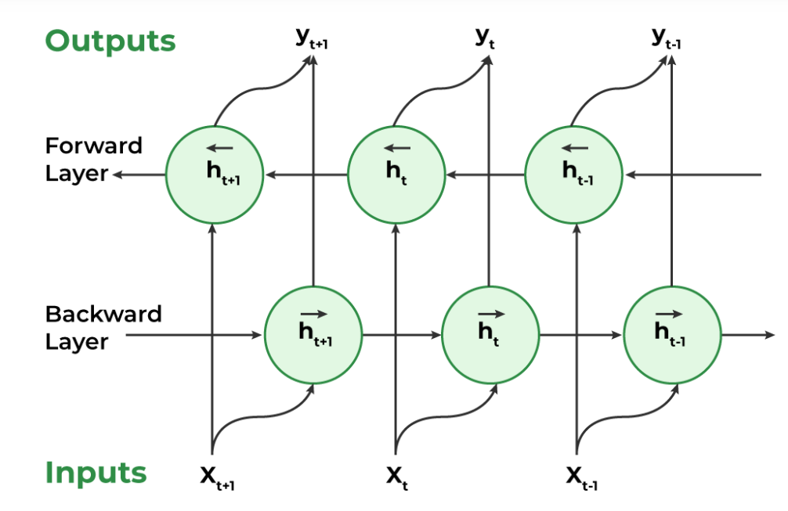
- Task Specific Integration:
Once trained, the biLM is used to generate embeddings for specific NLP tasks.
- ELMo embeddings are added to the input of a downstream model, such as a classifier.
- biLM can be either frozen to preserve general knowledge or fine-tuned on the specific task to improve performance.
- The downstream model learns to use these embeddings for improved predictions.

Code:
import tensorflow as tf
import tensorflow_hub as hub

elmo = hub.load("https://tfhub.dev/google/elmo/3")

def get_elmo_embedding(sentence):
embeddings = elmo.signatures["default"](tf.constant(sentence))["elmo"]
return embeddings

sentences = [
"The bank will approve your loan.",
"He sat by the bank of the river."
]
embeddings = get_elmo_embedding(sentences)
print(embeddings)

Output:
tf.Tensor(
[[[-0.00646184 0.00602162 -0.3559834 ... -0.64630026 0.01525996
0.258821 ]
[-0.9086765 -0.36578745 -0.07339747 ... 0.10579596 0.9989935
0.35678577]
[-0.88234663 -0.12698093 -0.01324169 ... -0.14876358 0.65635526
0.0101171 ]
...
[-0.65480745 0.4834412 -0.42673075 ... -0.5058821 -0.1037512
-0.02000746]
[-0.02840841 -0.04353216 0.04130162 ... 0.02583169 -0.01429836
-0.01650421]
[-0.02840841 -0.04353216 0.04130162 ... 0.02583169 -0.01429836
-0.01650421]]

[[-1.088259 -0.8831834 -0.15419099 ... -0.6398457 0.29121757
-0.6517152 ]
[ 0.02436765 0.27074525 0.6648065 ... 0.08937905 0.19568533
0.07570407]
[-0.09196179 -0.00226192 -0.4562363 ... -0.21427949 0.39564037
0.05189014]
...
[-0.54749244 -0.10532062 -0.04199721 ... -1.8377284 0.23080821
-0.18828934]
[-0.15414225 -0.29265624 -0.08370537 ... -0.05138047 0.5634001
-0.14172137]
[-0.01950646 0.1996505 -0.56394976 ... 0.06381172 1.3810718
1.0230731 ]]], shape=(2, 8, 1024), dtype=float32)

Doc2Vec:
Doc2Vec is also called a Paragraph Vector a popular technique in Natural Language Processing that enables the representation of documents as vectors. This technique was introduced as an extension to Word2Vec, which is an approach to represent words as numerical vectors. While Word2Vec is used to learn word embeddings, Doc2Vec is used to learn document embeddings.
Doc2Vec is the neural network approach that learn the distribution representation of documents. It is an unsupervised learning technique that maps each document to a fixed-length vector in a high-dimensional space. The vectors are learned in such a way that similar documents are mapped to nearby points in the vector space. This enables us to compare documents based on their vector representation.
Two Variants of Doc2Vec:
- Distributed Memory (DM)
- Distributed Bag of Words (DBOW)

  - Distributed Memory(DM):
Distributed Memory is the variant of Doc2Vec and extension of Word2Vec. The basic idea of DM is to learn the fixed length vector representation for each piece of text data (text, sentence, paragraph) by taking into account of context.
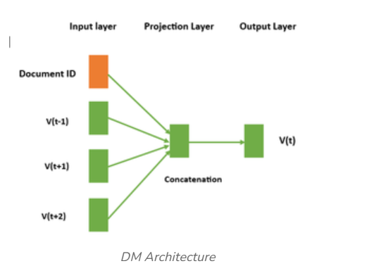
The neural networks takes two inputs : unique Document ID and context words. The context words are used to predict the target word and Document ID is used to capture the overall meaning of the document. The projection layer is responsible for creating unique word vector for each word in the input sequence and unique document vector for each document. These vectors are learned through the training process by optimizing a loss function that minimizes the difference between the predicted word and the actual target word. The output neural network takes the distributed representation of the context and predicts the target word.

- Distributed Bag of Words(DBOW):
DBOW is similar to Doc2Vec that focuses on understanding how words are distributed in a text, rather than their meaning.
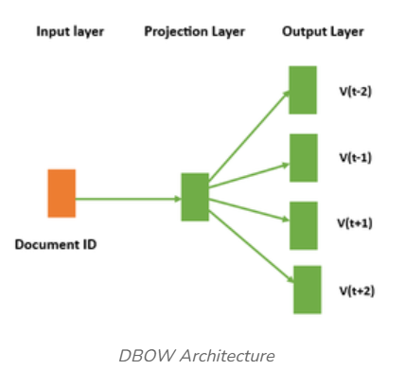
In the DBOW architecture, each document is represented by a unique vector representation without using separate word vectors. The model predicts words in a document using only the document vector, treating the document as a bag of words without considering word order. DBOW trains faster than DM but may capture less semantic meaning.

Code:
from gensim.models.doc2vec import Doc2Vec, TaggedDocument
from nltk.tokenize import word_tokenize

data = ["This is the first document",
"This is the second document",
"This is the third document",
"This is the fourth document"]

tagged_data = [TaggedDocument(words=word_tokenize(doc.lower()),tags=[str(i)])for i, doc in enumerate(data)]

model = Doc2Vec(vector_size=20,min_count=2,epochs=50)
model.build_vocab(tagged_data)
model.train(tagged_data,total_examples=model.corpus_count,epochs=model.epochs)

document_vectors = [model.infer_vector(word_tokenize(doc.lower())) for doc in data]

for i,doc in enumerate(data):
print("Document",i+1,":",doc)
print("Vector:",document_vectors[i])
print()

Output:
Document 1 : This is the first document
Vector: [ 0.00035521 -0.02381072 -0.01072136 -0.0032873 0.00326507 -0.00805133
-0.00748102 -0.00577668 0.02071457 -0.00307068 -0.01295568 -0.01432002
-0.01146988 -0.01584215 -0.00688417 0.01798569 -0.02053943 -0.00550879
0.00738143 0.0010723 ]

Document 2 : This is the second document
Vector: [ 0.00058139 0.02049809 -0.01756831 0.01685013 -0.01439014 0.003887
-0.02336952 0.0056388 0.00953162 -0.01496325 0.00064372 0.02287737
-0.02465491 -0.00332581 0.01134276 -0.00572409 0.02145219 0.0193494
-0.00271343 0.01091877]

Document 3 : This is the third document
Vector: [ 0.0160574 -0.00725299 -0.02446108 0.00759402 0.00248579 -0.01274743
0.01096968 0.01356071 0.01134324 0.00200457 0.01467603 0.01559718
0.00992552 0.0118179 -0.02501293 0.02163726 0.02282941 0.01128489
-0.02289733 0.00417529]

Document 4 : This is the fourth document
Vector: [ 6.8485592e-03 1.7881015e-02 1.4756878e-02 -5.3506088e-03
-1.8969204e-02 1.6961496e-02 -3.5659417e-03 2.0324437e-02
3.6026917e-03 -1.4922041e-02 -6.9169812e-03 -1.6683649e-03
-2.0818957e-03 1.7979376e-03 1.2819964e-02 7.5965920e-03
4.6380806e-05 -3.2309443e-03 -5.9710146e-04 2.4299705e-02]
RoBERTa (Robustly Optimized BERT Pretraining Approach):
RoBERTa kept the same architecture like BERT, but refined the training process to achieve better results.
Key Differences between BERT and RoBERTa:
RoBERTa shares the same transformer encoding as BERT, but it changes:
  - Removal of Next Sentence Prediction(NSP):
BERT uses NSP to determine whether two sentences appeared sequentially in original corpus and it help the model capture sentence level relationships.
RoBERTa removes NSP entirely as it contribute less and focuses solely on Masked Language Modeling(MLM) allowing the model to concentrate on learning better token – level contextual representations.

  - Dynamic Masking Strategy:
BERT uses static masking where input tokens are masked once during preprocessing and the same masked patterns are used for every training epoch.
RoBERTa replaces this with dynamic masking in which masked positions are sampled randomly during each training pass. This ensures the model encounters diverse masking patterns, leading to better generalization and more robust contextual understanding.

- Larger Batch Sizes and Extended Training Time:
RoBERTa improved BERT’s training by using much larger batch sizes (up to 8,000 sequences) and training for more steps. BERT uses batch size up to 256 sequences It also used better learning rates and optimization schedules. These improvements made training more stable and helped the model learn deeper language patterns. Unlike BERT, RoBERTa achieved better performance without changing the architecture. It also removed some of BERT’s training limitations, allowing the model to utilize data more effectively and achieve higher accuracy on NLP tasks.

- Extended Training Corpus:
RoBERTa was trained on a much larger and more diverse dataset than BERT. While BERT used 16GB of text from Wikipedia and BookCorpus, RoBERTa was trained on over 160GB of text including Common Crawl News, OpenWebText, Stories dataset, Books, and Wikipedia. This larger dataset exposed the model to richer language patterns and different writing styles. As a result, RoBERTa achieved better generalization and improved performance on real-world NLP tasks.
Code:
from transformers import pipeline

classifier = pipeline("sentiment-analysis",model="roberta-base")

result = classifier("The movie was absolutely fantastic!")

print(result)

Output:
